**Create a Header and Footer Experience Fragments**

Link the header fields to the destinations

In footer add the list of books and link them to the respective pages

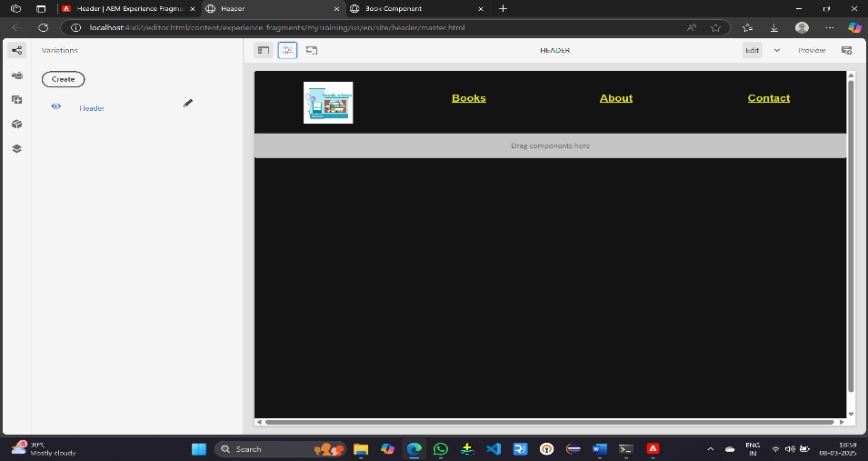

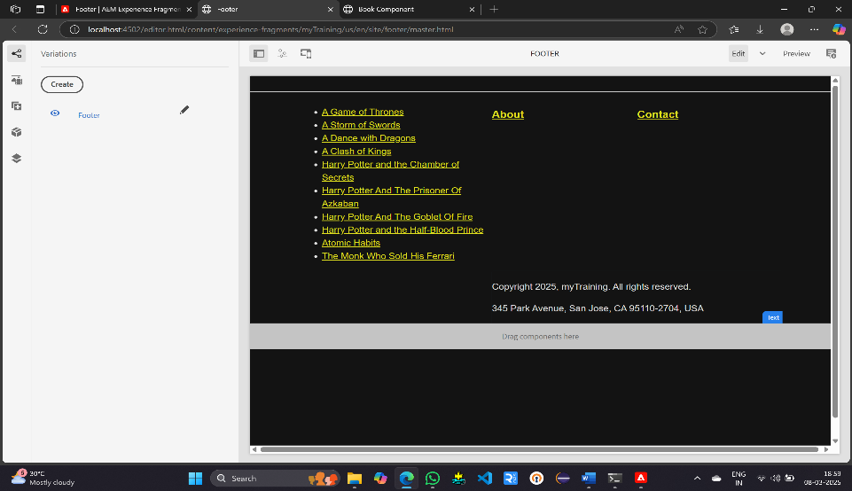

**Create the Book Component**

Create the book component with title, text and image fields

Add header and footer experience fragments in the book component

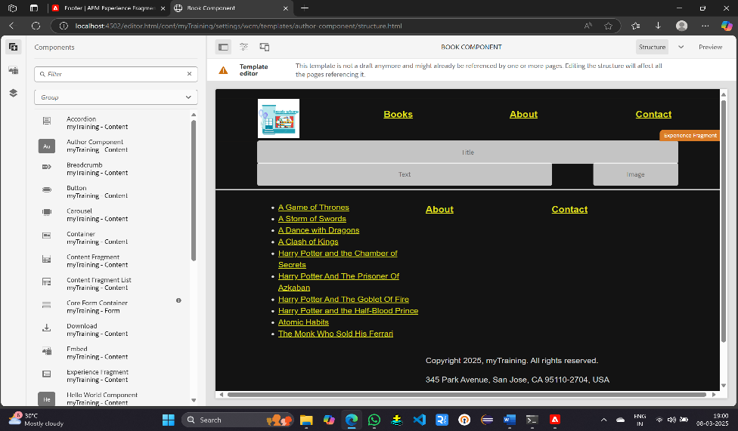

**Create about, contact and 10 book pages**

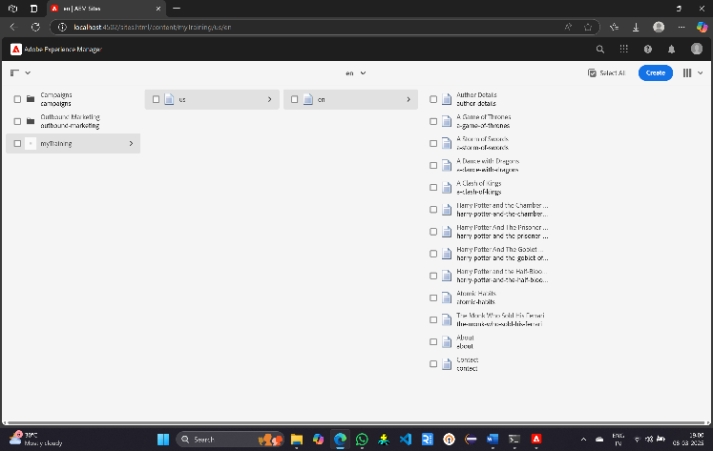

**Output**



